Static Routing Basic Configuration

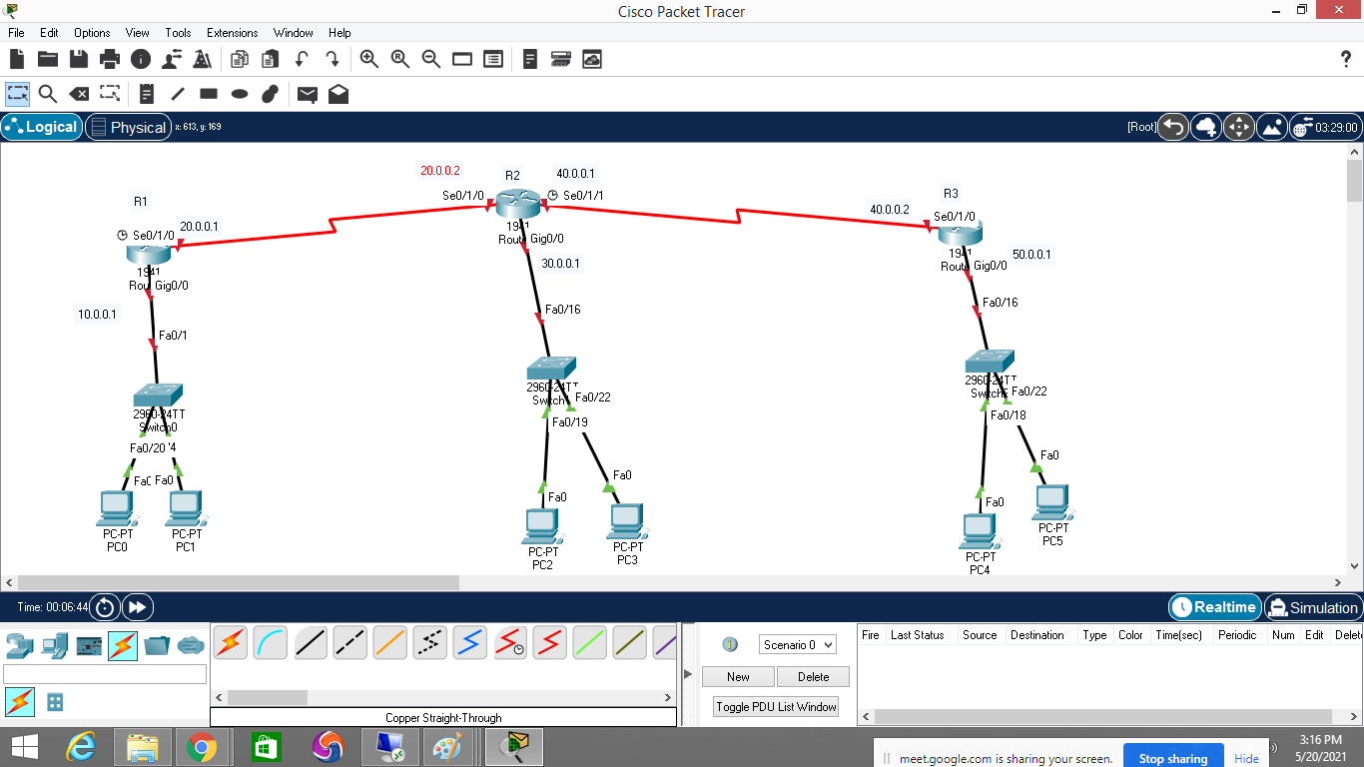

R1 interface configuration

Would you like to enter the initial configuration dialog? [yes/no]: no

Router>enable

Router#conf t

Router(config)#hostname R1

R1(config)#interface g0/0

R1(config-if)#ip address 10.0.0.1 255.255.255.0

R1(config-if)#no shutdown

R1(config-if)#interface se0/1/0

R1(config-if)#ip address 20.0.0.1 255.255.255.0

R1(config-if)#no shutdown

R2 interface configuration

Router>enable

Router#conf t

Router(config)#hostname R2

R2(config)#interface se0/1/0

R2(config-if)#ip address 20.0.0.2 255.255.255.0

R2(config-if)#no shutdown

R2(config-if)#interface g0/0

R2(config-if)#ip address 30.0.0.1 255.255.255.0

R2(config-if)#no shutdown

R2(config-if)#interface se0/1/1

R2(config-if)#ip address 40.0.0.1 255.255.255.0

R2(config-if)#no shut

R2(config-if)#no shutdown

R3 interface configuration

Router>en

Router#conf t

Router(config)#hostname R3

R3(config)#interface se0/1/0

R3(config-if)#ip address 40.0.0.2 255.255.255.0

R3(config-if)#no shutdown

R3(config-if)#interface g0/0

R3(config-if)#ip address 50.0.0.1 255.255.255.0

R3(config-if)#no shutdown

Cmds

R1#show ip route=>to check the routing table

It contain best and possible network paths

R1 static routing configuration

R1(config)#ip route 30.0.0.0 255.255.255.0 20.0.0.2

R1(config)#ip route 50.0.0.0 255.255.255.0 20.0.0.2

R1(config)#ip route 40.0.0.0 255.255.255.0 20.0.0.2

R2 static routing

R2(config)#ip route 10.0.0.0 255.255.255.0 20.0.0.1

R2(config)#ip route 50.0.0.0 255.255.255.0 40.0.0.2

R3 static routing

R3(config)#ip route 30.0.0.0 255.255.255.0 40.0.0.1

R3(config)#ip route 20.0.0.0 255.255.255.0 40.0.0.1

R3(config)#ip route 10.0.0.0 255.255.255.0 40.0.0.1

